Preliminary Rounds

We had great start to the State 4 Wall Singles Championships Saturday at Total Sports. Here are the results to date by division:
Open Division:
Number 1 seed Jim Karner defeated dual division player Craig Sickmiller in 2 games. Game 1 was a battle but Jim pulled out 5 or 6 aces on the right side to win 21-19.
No 2 Seed Pat Oliver advanced by forfeit as he was supposed to play me Monday night. I took a shot the eye playing a pick up game Saturday and the doctor has shut me down for a week. (All will be fine.)
The 3/6 and 4/5 match ups were determined by a WPH style draw. Phil Kirk drew the one card and selected to play Pat Myers. He wanted a tough match as he is preparing to play in the masters singles in Portland. Pat Myers was too much and beat Phil in two games. Phil will be at the bottom of the 60s age bracket and luckily will face guys not quite as fast as Pat. Good luck Phil.
In the 3/7 match up, Mike Fagan defeated Billy Sidebottom Jr. in two games.
Tonight at the Detroit Athletic Club, Mike Fagan will play Pat Oliver and Jim Karner will play Pat Myers. The winners will play Friday night at 5 PM at the DAC.
A Division
In the A division we had 5 players. In the 4/5 match up, Tyler Sickmiller beat Dan Taylor in a great match 11 to 10 in the tie breaker. He advanced to play Ryan Inman who beat Tyler in 2 games.
In the other bracket, Kyle Casey beat Tommy Fabbri in a close match. Kyle will play Ryan Friday night at the DAC.
50s Division
In the 50s Division, we had 4 players. In a match up of last years finals, Ted Grammatico beat Chris Mebus in two games. In the other side of the bracket, Craig beat Chris Monsour. Craig played Ted on Sunday and won the title in two games.
55s Division
In the 55 Division we had a nice turnout with 9 players. the 8/9 match up featured Brian Linne vs. Sam Gachupin. Brian advanced in two games to play number one seed Chris Monsour. Chris beat Brian in two games.
The other match ups were also determined by a draw. Duane Costanzo drew the 1 card and selected Dale Chimenti. That almost backfired as Dale pushed Duane in two tough games. Duane did survive to advance and play Paul Straetmans in the semi-finals.
Paul Straetmans played Jim Lafluer in the 3/6 match up. Paul advanced in two games to play Duane Costanzo in the semi-finals. Paul beat Duane in two games and will play in the finals Friday night.
In the 4/5 match up, it was a great battle between Mark Mller and Bob Balch. THis match match went to a tie breaker. Miller used his endurance and rally skills to win the match and advance to the semi-s vs. Chris Monsour. Chris and Mark will play tonight at the DAC.
65s Division
We had 9 players in the 65s. With last year finalists playing a tournament in Erie, PA the same weekend, Jim Lowe and Rick Graham received first round byes. We used two round robins for the remaining 7 players.
In the first pool, Mike Howe and Presley Sims played a great match with PK coming from down 9 to 3 to win 11-10 in the tie break.
Angus McIntyre defeated Charlie Doyle and PK Sims to emerge from this pool play and will face Jim Lowe tonight at the DAC.
In the other pool, Eddie Green defeated Tom Myers and Rich Seguin to advance to the semi-finals. He will play Rick Graham at the DAC tonight.
I will update the results tomorrow and provide details on the Friday night finals. We will have food and beer Friday night and it should be a great event.
PS - Thanks to Total Sports form hosting the event and Bud Yates for running the check in desk.

SEMI- FINALS
We had some great semi-final matches on Wednesday and the finals are set for tonight.
Open Division:
Defending champ and number one seed Jim Karner advanced to the finals beating Pat Myers in two close games. He will face Mike Fagan tonight at 6 PM.
Mike Fagan beat Pat Oliver in a tie breaker. Pat rolled in game one with serves and passes and kills all working. In game two Fagan started to get his back wall going. He surged to early lead. The crowd was hoping for a close tie breaker but Oliver seemed to hit a mental or physical wall and Fagan cruised through the rest of the games to win the match.
A Division:
Kyle Casey vs. Ryan Inman - 5 PM.
Both players are ready to step up to the open division and one of them will have to after they battle it out tonight.
55s Division:
Chris Monsour vs. Paul Straetmans - 5 PM
Both these guys play weekly matches against each other so they will be no surprises. It should be a great battle and a vegas "pick em" game.
65s Division
Lowe vs. Graham at 5:30 PM
Jim Lowe won his semi finals over Angus McIntrye. Angus battled and had some runs but Jim's serve was too much.
Rick Graham beat Ed Green in two games. Ed had some stretches of success but Rick was too steady and his back wall kill was the difference.
The Graham Lowe match should be a great one. This Magic vs. Bird, Connors McEnroe, Last year was a tie breaker and I would expect the same this year.
Tacos and beer for players and MHA members. Please come down and watch.
he 4 Wall season wrapped up this past Friday with some great matches.
Open Division
Jim Karner vs. Mike Fagan
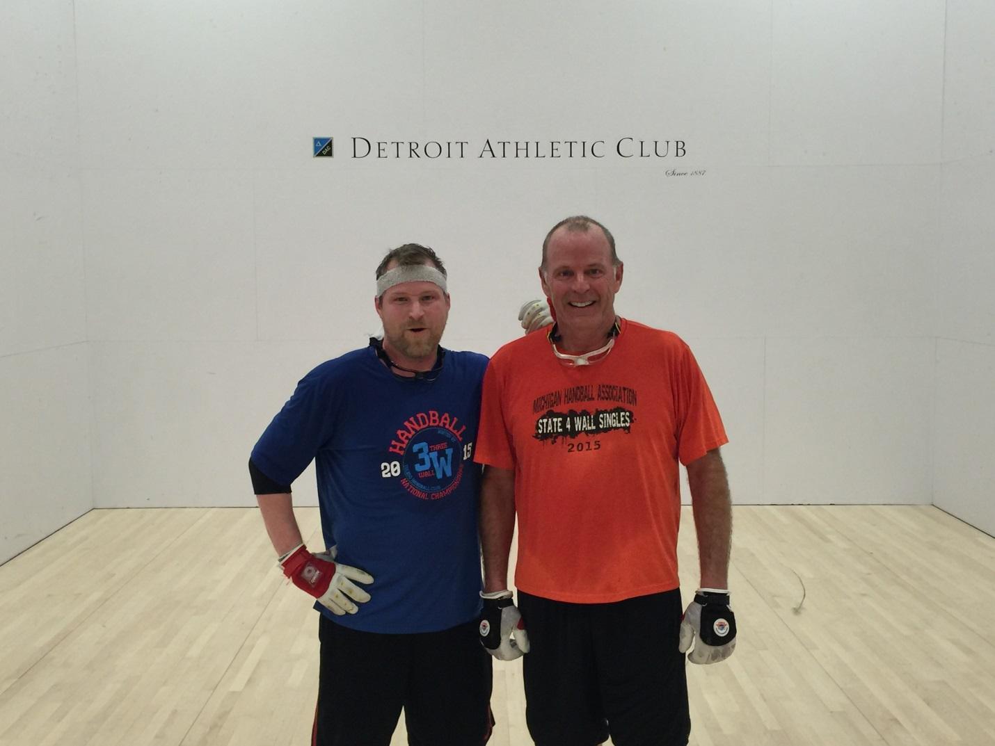
Jim Karner defended his title beating Mike Fagan in 2 games. Mike started to shoot more from the back wall in game two to make it pretty even through 2/3 into the game. However, Jim used his power and control to move Mike around and create a few more back wall set ups and put the match away.
A Division:
Kyle Casey vs. Ryan Inman -.
This is was tight battle with both players returning nearly every shot the other hit. Game one went to Casey as Inman seemed to have a bit too much big match energy to put the ball away.
In game two Inman had 19 points and the lead and it was looking like a tie breaker. However, Casey used his strong re-kill game to come back and earn the title.
55s Division:
Chris Monsour vs. Paul Straetmans
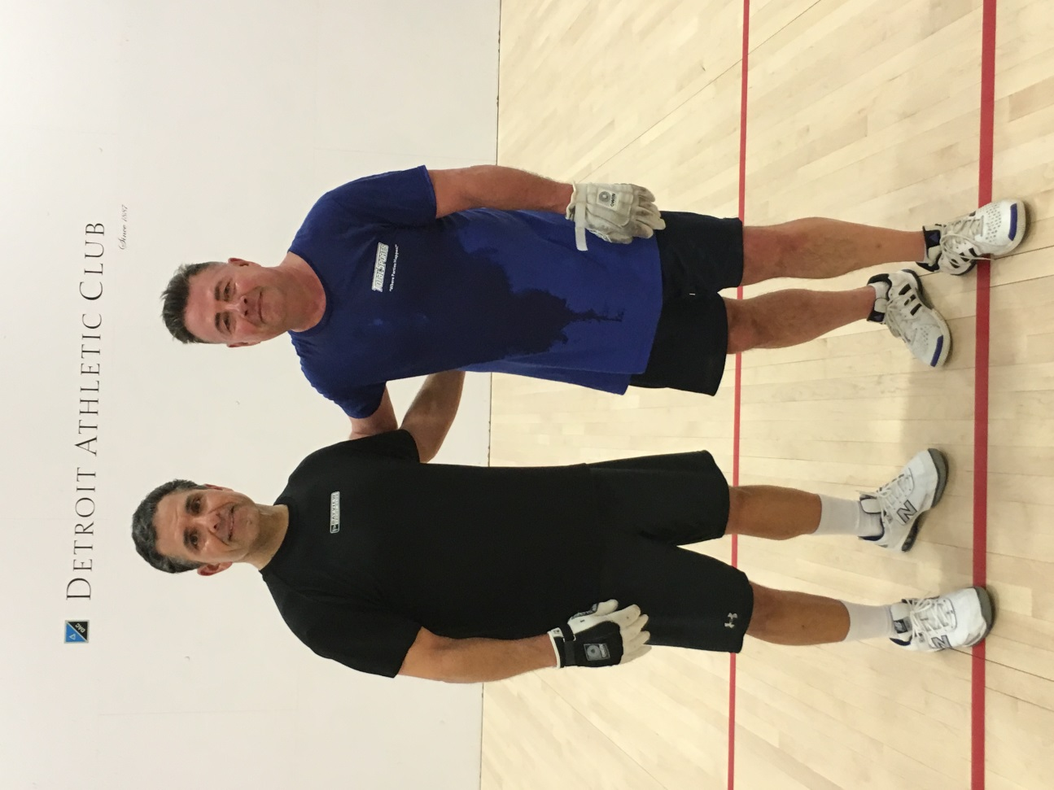
Chris came out strong and took game one easily. In game two, Paul got warm and it was a tight game. However, Chris played very steady and determined and pulled away to earn the title.
65s Division
Lowe vs. Graham
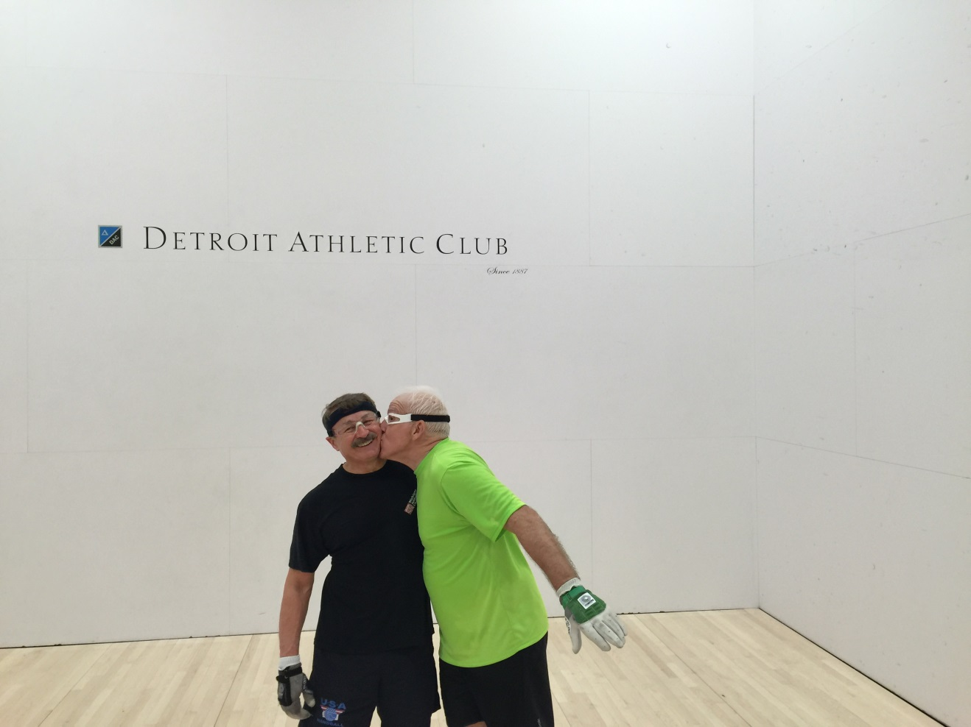
In what seems like an annul battle as old as Ohio State vs. Michigan, Jim Lowe beat rival and great friend Rick Graham in two games. Jim served tough and stayed away from the back wall to earn the title
Thanks to all who participated. The 3 Wall Tournament Dates have been set and are posted on the website. We will have the doubles in mid-July at St. Clair Shores and the singles in mid- August at Belle Isle.

